**Java Script repo 1**

**12-**june**-2021**

**15-june-2021**

**Day 1**

**Introduction**

JavaScript (js) is a light-weight object-oriented programming language which is used by several websites for scripting the webpages. It is an interpreted, full-fledged programming language that enables dynamic interactivity on websites when applied to an HTML document. It was introduced in the year 1995 for adding programs to the webpages in the Netscape Navigator browser.

**Some Application of JavaScript: -**

* Client-side validation,
* Dynamic drop-down menus,
* Displaying date and time,
* Displaying pop-up windows and dialog boxes (like an alert dialog box, confirm dialog box and prompt dialog box),
* Displaying clocks etc.

In this file we have details about DOM i.e. Document Object Model.

In this in one side we have html code and other side we have DOM-JS view, in this we have basically three types of node : -

1. Element Node (Every html element is an element node )
2. Attribute Node(these are node which are accessed by node or by index)
3. 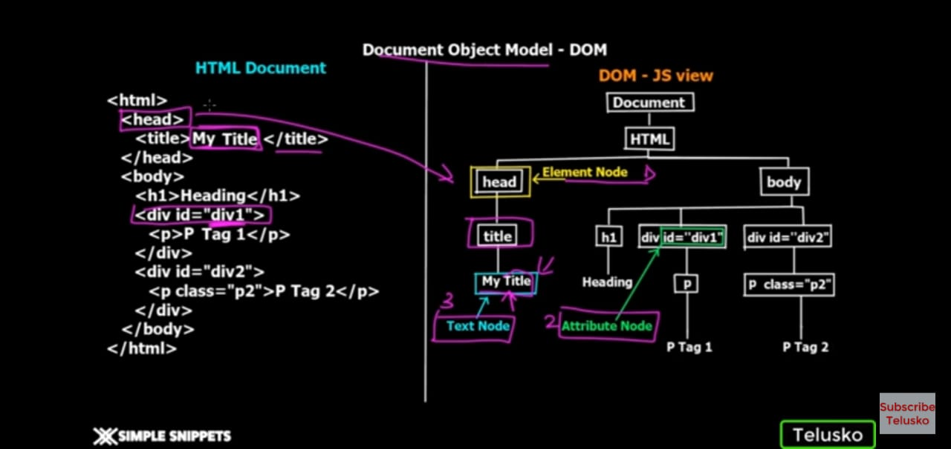Text Node(these are node under which we write text)

**Things Require to run a JavaScript file :-**

* Visual Studio code (or any text editor)
* Google chrome browser

1. **First java Script program :-**

Hello world

Html file :-

<html>

    <head>

//this is for single line comment ……….

/*this is multi line comment

We can write anything here

*/

        <title> My Title</title>

        <script src="demo.js" type="text/javascript">//for calling js file …

            //document.write("hello world");

        </script>

    </head>

    <body>

    </body>

</html>

Js file :-

document.write("<h1>External file </h1>");

document.write("<h2>hello mananjay Roy </h2>")

**connection with live server**

1. For this we need to click on extension and then we need to search live server .
2. After this we need to install live server.
3. Then come to the main ide and in bottom task bar you will find go live so as you click here the live server starts performing .

**Operators in JavaScript**

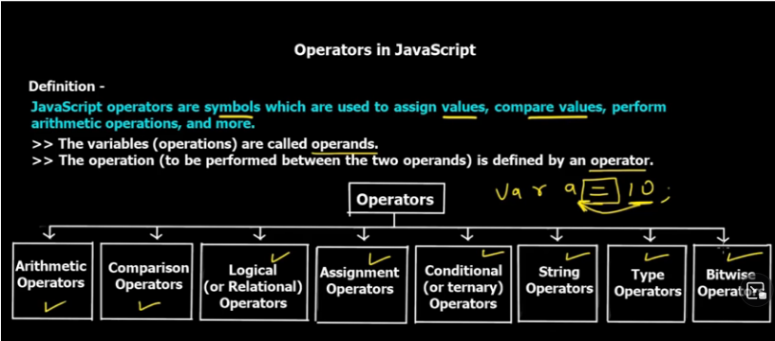

**Arithmetic operators:-**

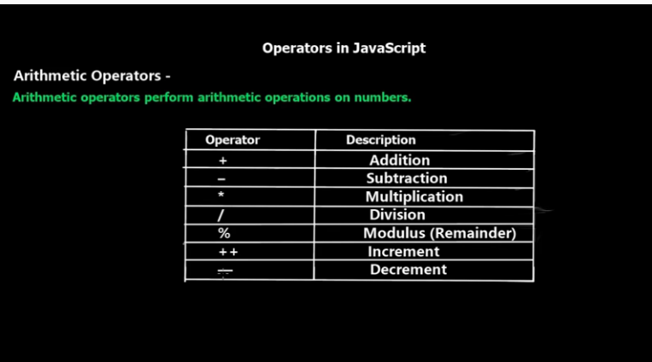

**Comparator operator**

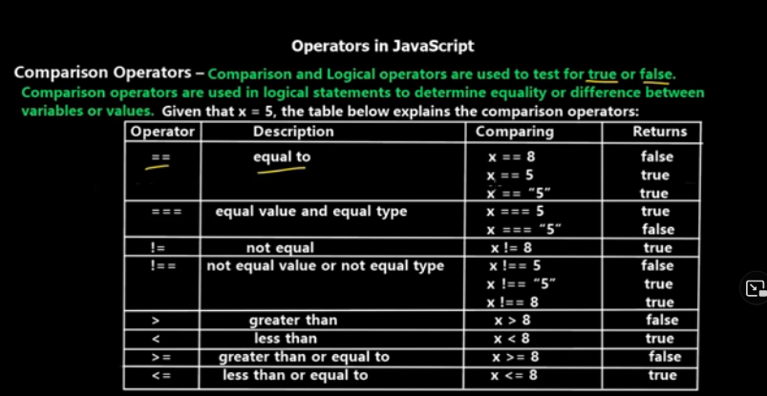

**Logical Operator**

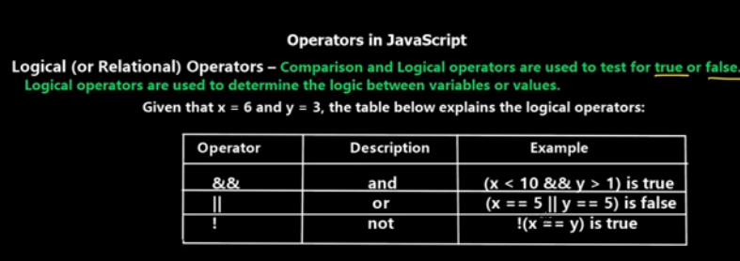

**Assignment operators**

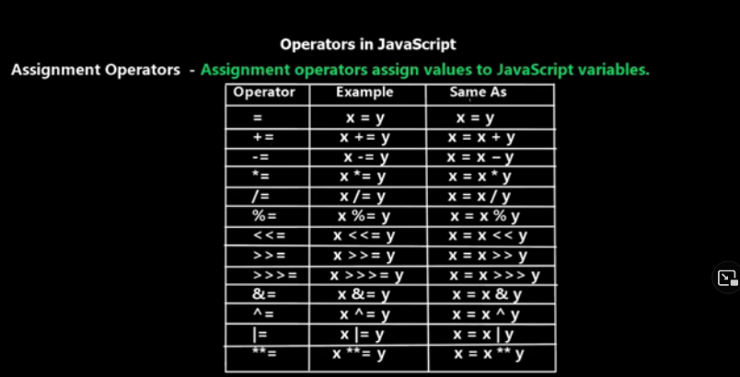

**Conditional operator**

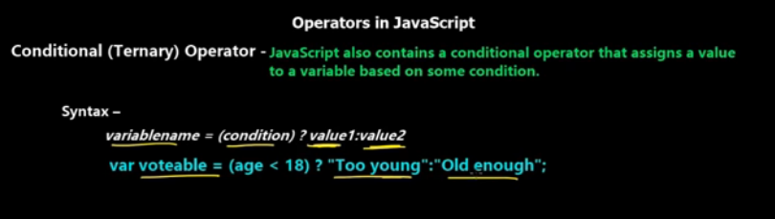

**String operator**

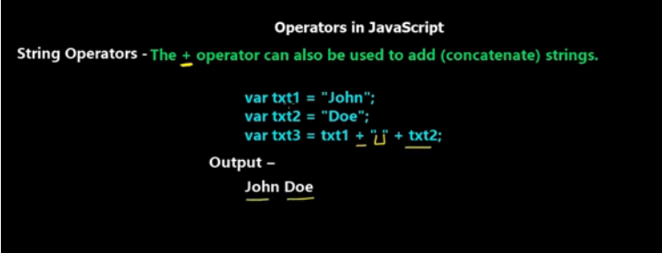

**Type operator**

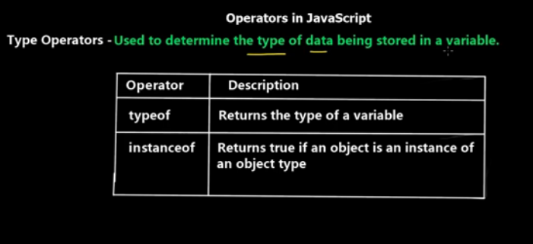

**Bit wise operator**

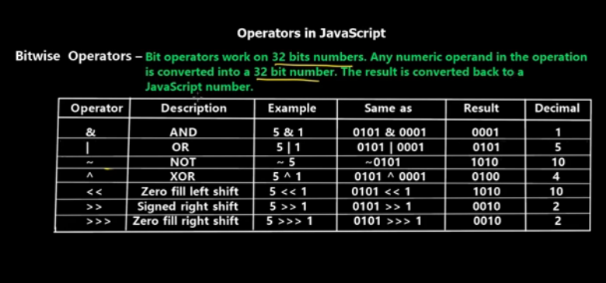

**Some basic operator code:-**

<html>

<head>

    <title> operator</title>

    <script type="text/javascript">

   //addtion

   var a=3;

    var b=5;

    var  result= a+b;

    var result1=a+b+" Mananjay "+a+b;

        document.write("<h1>Result= "+result+"</h1>");

        document.write("<h1>Result= "+result1+"</h1>");

    </script>

</head>

<body>

    <h1></h1>

</body>

</html>

**If else control statement**

<html>

<head>

    <title>If Else</title>

    <script type="text/javascript">

    /*

        1. Find wether number is even or odd

        2. Find the number is positive, negative, zero

        2. Find if a number is positive and even.

    */

        var a=8;

         //for 1

        if(a%2==0)

        {

            document.write("<h3>Even</h3>");

        }

        else

        {

            document.write("<h3>odd </h3>");

        }

        //for 2

        if(a==0)

        document.write("<h3>zero </h3>");

        else if(a>0)

        document.write("<h3>positive</h3> ");

        else

        document.write("<h3>negative </h3>");

        //for 3

        if(a>0 && a%2==0)

        document.write("<h3>the number is positive as well as even </h3>");

        else

        document.write("<h3>not a positive or even number </h3>");

    </script>

</head>

<body>

</body>

</html>

**Switch case**

<html>

    <head>

        <title>Switch</title>

        <script type="text/javascript">

        /*

        Find the day of week by accepting the number ..

        1-> sunday

        2-> monday  ...

        */

       var day=22;

       switch(day)

       {

            case 1:

                document.write("<h3>sunday</h3>") ;

                break;

            case 2:

                document.write("<h3>Monday</h3>") ;

                break;

            case 3:

                document.write("<h3>tuesday</h3>") ;

                break;

            case 4:

                document.write("<h3>wednesday</h3>") ;

                break;

            case 5:

                document.write("<h3>Thusday</h3>") ;

                break;

            case 6:

                document.write("<h3>Friday</h3>") ;

                break;

            case 7:

                document.write("<h3>Saturday</h3>") ;

                break;

            default:

                    document.write("<h3>wrong input </h3>")     ;

       }

        </script>

    </head>

    <body>

    </body>

</html>

It can take input as number string and also Boolean

**Looping statements in JavaScript**

1. For loop;
2. while loop
3. do while loop

**Functions in JavaScript**

* functions are one of the following building block of JavaScript;
* Function is a set of operation that performs a task or calculate a value.
* It is designed to perform a particular task
* And this is executed when someone invoke it.
* <html>
* <head>
* <title>Function</title>
* <script type="text/javascript">
* /*
* Write a program to add 2 numbers and print result.
* */
* function add2Number()
* {
* var a=5;
* var b=9;
* var total=a+b;
* document.write("<h1>sum of two number :"+total+"</h1>");
* }
* //parameterized function ........
* function add2Number1(a,b)
* {
* var total=a+b;
* document.write("<h1>sum of two number :"+total+"</h1>");
* }
* //returned function.....
* function add2Number2(a,b)
* {
* var total=a+b;
* return total;
* }
* add2Number();//function call....
* add2Number1(5,4);
* add2Number1("mananjay ","roy");
* output=add2Number2("Dhananjay ","Roy");//return function calling ...
* document.write("<h1>sum of two number :"+output+"</h1>");
* </script>
* </head>
* <body>
* </body>
* </html>

**We also have alert(num);**

It’s give pop up in browser tab

**Array in JavaScript**

<html>

    <head>

        <title>Array</title>

        <script type="text/javascript">

        var car1="maruti";

        var car2="tata";

        var car3="volvo";

        var cars=["maruti","tata","volvo1"];

        document.write("<h2>"+cars+"</h2>");//for printing all set ...

        document.write("<h2>"+car1+"</h2>");//for printing particular element...

        document.write("<h2>"+cars[1]+"</h2>");//for printing value by index  number

        //for printing all values at a time...

        cars.push("kia");//we can push string also

        cars.push(2);///here we can push integer also

        for(var i=0;i<cars.length;i++)

        {

            document.write("<h2>"+cars[i]+"</h2>");

        }

        </script>

    </head>

</html>

**Some key point for JavaScript in array**

* In this array size is not fixed we can increase size as it follows dynamic memory allocation for JavaScript.
* And also in this we can store dissimilar data type in a single array.

**Concepts on Objects in JavaScript**

**Code :**

<html>

    <head>

        <title>Introduction to objects</title>

        <script type="text/javascript">

        /*

            this is  normal object creation using method

        */

        var Car= {//creation of object file

            car_brand :"Tesla ",

            model:"T110X ",

            price:35000,

            teslaAutoPilot :function()//method creation inside object

            {

                document.write("<h2>This is a car run on autopilot mode</h2>");

            },

            linespace : function()

            {

                document.write("<h2>===============*******=================</h2>");

            }

        }

        document.write("<h2>"+Car.car_brand+"</h2>");

        document.write("<h2>"+Car.model,Car.model+"</h2>")

        document.write("<h2>"+ Car.model +Car.price +"</h2>");

        Car.teslaAutoPilot();

        Car.linespace();

        /*

        now we are going to learn about object constructor

        or we can say function consttructor

        */

        function Cars(car_brand1,model1,price1)

        {

            this.car_brand1=car_brand1;

            this.model1=model1;

            this.price1=price1;

            this.teslaAutoPilot1 = function()

            {

                document.write("<h2>This is a car run on autopilot mode</h2>");

                document.write("<h2>"+car_brand1, model1, price1+"</h2>");

            }

        }

        var c1=new Cars("Tesla ","T110x ",350000);

        var c2=new Cars("TATA ","Nexon ",90000);

        c1.teslaAutoPilot1();

        c2.teslaAutoPilot1();

        Car.linespace();//this is for line end ..............

        // it tells details about type..........

        document.write(typeof(Cars));

        document.write("<h2>"+typeof(Car.car_brand)+"</h2>");

        document.write("<h2>"+typeof(Car.price)+"</h2>");

        Car.linespace();//this is for line end ..............

        /*

        If i need to add one more property in under Cars...

        so we can directlyy add it .......

        */

        Car.fuelType="Electric";

        document.write("<h2>"+Car.fuelType+"</h2>");

        //we can also delete properties from car method ...

        delete Car.price;

        document.write("<h2>"+Car.price+"</h2>");

        //we an also achange the data type of variable

        Car.price="35000";

        document.write("<h2>"+Car.price+"</h2>");

        document.write("<h2>"+typeof(Car.price)+"</h2>");

        Car.linespace();

        </script>

    </head>

    <body>

    </body>

</html>

**Starting with DOM manipulation**

<html>

    <head>

        <title>Dom manipulation</title>

        <script type="text/javascript">

        function buttonClick()

        {

            //callig a action to a button..........

            document.getElementById("heading2").innerHTML="Mananjay ";

            alert("button clicked");

        }

        function buttonclick1()

        {

            var str =document.getElementById("heading3").innerHTML="95% loyal";

            alert(str);

        }

        function fn1()

        {

            var str = document.getElementById("text1").value;

            var str1 = document.getElementById("text2").value;

            if(str==str1)

            alert(str+" Sucessfully log in ");

            else

            alert(str+" wrong username or password");

        }

        </script>

    </head>

    <body>

        <button onclick="buttonClick()">Click me </button>

        <h2 id="heading2"> Some Text must be there</h2>

        <button onclick="buttonclick1()"> sign up</button>

        <h2 id="heading3"> Loyality test</h2>

        <input type="text" id="text1" placeholder="Enter yout name ">

        <br><br>

        <input type= "password" id="text2" placeholder="Enter your password">

        <br><br>

        <button onclick="fn1()" id="button3">Sign in </button>

    </body>

</html>

**Output:-**

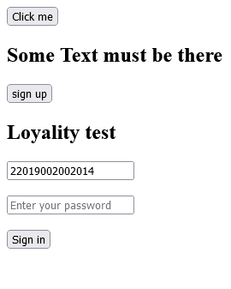

**Radio button added**

<html>

    <head>

        <title>Dom manipulation</title>

        <script type="text/javascript">

        function buttonClick()

        {

            //callig a action to a button..........

            document.getElementById("heading2").innerHTML="Mananjay ";

            alert("button clicked");

        }

        function buttonclick1()

        {

            var str =document.getElementById("heading3").innerHTML="95% loyal";

            alert(str);

        }

        //details for log in page

        function fn1()

        {

            var str = document.getElementById("text1").value;

            var str1 = document.getElementById("text2").value;

            if(str==str1)

            alert(str+" Sucessfully log in ");

            else

            alert(str+" wrong username or password");

        }

        var Line= {

            linespace : function()

            {

                document.write("<h2>===============*******=================</h2>")

            }

        }

        //Line.linespace();

        function fn2()

        {

            var radio1=document.getElementById("radio1");

            var radio2=document.getElementById("radio2");

            if(radio1.checked==true)

                alert("The channel selected as "+radio1.value);

            else if(radio2.checked==true)

                alert("the channel selected as "+radio2.value);

            else

                alert("NO channel selected");

        }

        </script>

    </head>

    <body>

        <button onclick="buttonClick()">Click me </button>

        <h2 id="heading2"> Some Text must be there</h2>

        <button onclick="buttonclick1()"> sign up</button>

        <h2 id="heading3"> Loyality test</h2>

        ====================*********====================<br>

            <b>User name</b><input  type="text" id="text1" placeholder="Enter yout name "></input>

            <br><br>

            <b>Password </b><input type= "password" id="text2" placeholder="Enter your password">

            <br><br>

            <b>Gender </b><br>

            <input name="grp1" type ="radio" id="radio1" value="male" >Male</input> <br>

            <input name="grp1" type ="radio" id="radio2"value="female" >Female</input><br><br>

            <button onclick="fn2()" id="button3">check </button>

            <button onclick="fn1()" id="button3">Sign in </button>

    </body>

</html>

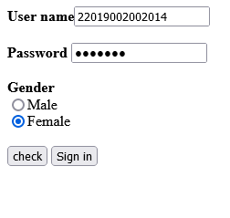

<html>

    <head>

        <title>Dom manipulation</title>

        <script type="text/javascript">

        function buttonClick()

        {

            //callig a action to a button..........

            document.getElementById("heading2").innerHTML="Mananjay ";

            alert("button clicked");

        }

        function buttonclick1()

        {

            var str =document.getElementById("heading3").innerHTML="95% loyal";

            alert(str);

        }

        //details for log in page

        function fn1()

        {

            var str = document.getElementById("text1").value;

            var str1 = document.getElementById("text2").value;

            if(str==str1)

            alert(str+" Sucessfully log in ");

            else

            alert(str+" wrong username or password");

        }

        var Line= {

            linespace : function()

            {

                document.write("<h2>===============*******=================</h2>")

            }

        }

        //Line.linespace();

        function fn2()

        {

            var radio1=document.getElementById("radio1");

            var radio2=document.getElementById("radio2");

            if(radio1.checked==true)

                alert("The channel selected as "+radio1.value);

            else if(radio2.checked==true)

                alert("the channel selected as "+radio2.value);

            else

                alert("NO channel selected");

        }

        //for drop down box and whiscever is selected we need to take that value

        function fn3()

        {

            var select=document.getElementById("selectbox");

            alert(select.options[select.selectedIndex].value);

        }

        //for manupualating get element by Tag name

        function fn4()

        {

            var para=document.getElementsByTagName("p");

            para[0].style.fontSize=25;

            para[1].style.color="green";

            para[2].style.fontWeight="bold";

            para[3].style.fontStyle="italic";

            for(var i=4;i<para.length;i++)

            {

                para[i].style.color="red";

            }

        }

        </script>

    </head>

    <body>

        <button onclick="buttonClick()">Click me </button>

        <h2 id="heading2"> Some Text must be there</h2>

        <button onclick="buttonclick1()"> sign up</button>

        <h2 id="heading3"> Loyality test</h2>

        ====================*********====================<br>

            <b>User name</b><input  type="text" id="text1" placeholder="Enter yout name "></input>

            <br><br>

            <b>Password </b><input type= "password" id="text2" placeholder="Enter your password">

            <br><br>

            <b>Gender </b><br>

            <input name="grp1" type ="radio" id="radio1" value="male" >Male</input> <br>

            <input name="grp1" type ="radio" id="radio2"value="female" >Female</input><br><br>

            <button onclick="fn2()" id="button3">check </button>

            <button onclick="fn1()" id="button3">Sign in </button>

            <br><br>

            <select id="selectbox">

                <option value="Mechanical">Mechanical</option>

                <option value="Computer Science">Computer Science</option>

                <option value="Electrical">Electrical</option>

                <option value="Civil">Civil</option>

            </select>

            <button onclick="fn3()" id= "button4">Select box</button>

            <p>This is my paragraph 1</p>

            <p>This is my paragraph 2</p>

            <p>This is my paragraph 3</p>

            <p>This is my paragraph 4</p>

            <p>This is my paragraph 5</p>

            <p>This is my paragraph 6</p>

            <p>This is my paragraph 7</p>

            <p>This is my paragraph 8</p>

            <button onclick="fn4()" id= "button4">On Click</button>

    </body>

</html>

